1.učna ura MONDAY – 16th March 2020
DZ str.28, 29 | DZ 30, 31
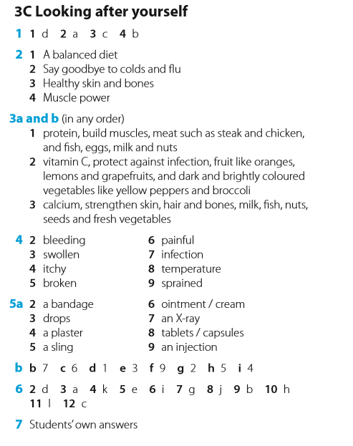 | 