REŠITVE PRVA UČNA URA 16.3-20.3.2020
učbenik: str. 47/4a
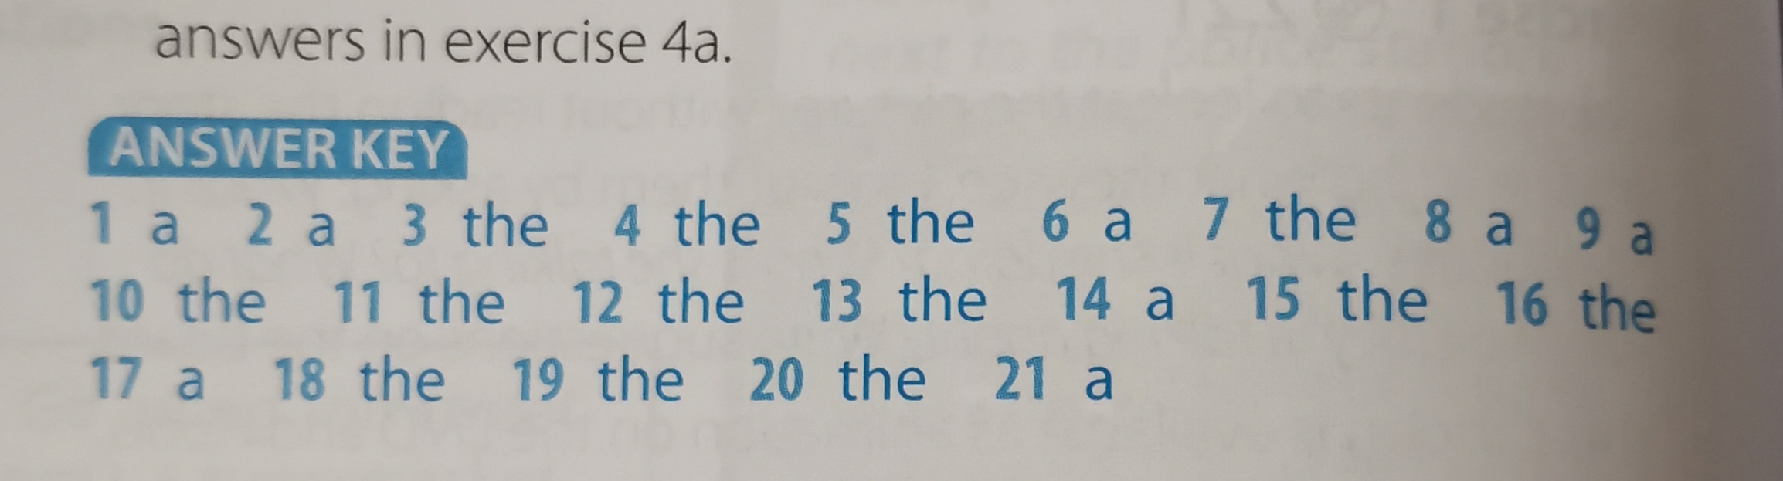
DZ 36 in 37
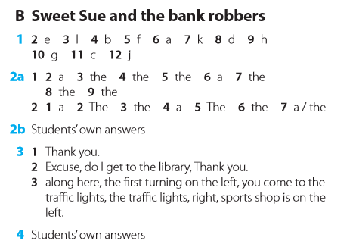

INDEFINITE ARTICLE  NEDOLOČNI ČLEN | DEFINITE ARTICLE  DOLOČNI ČLEN | ZERO ARTICLE
A/AN | THE | / - BREZ ČLENA
Uporabljamo le pri števnih samostalnikih v EDNINI.  - Ko samostalnik omenjamo prvič, o njem še nič ne vemo, ni točno določen.  You will come to A roundabout.  I saw A girl in the street. (neko deklico)  - Eden izmed mnogih, ki obstajajo  There is A shop at the end of the street.  - Pred poklici  My aunt is A doctor.  He is AN engineer.  - Količine  He drove 5 miles AN hour.  We bought A kilogram of apples.  - V frazah ali vzklikih  A lot of  A few  A little  I had A shower.  What A cute boy!  What A nice house! | Lahko uporabljamo v ednini ali množini, pri števnih in neštevnih samostalnikih.  - Ko samostalnik omenjamo drugič ali ponovno, je točno določen, vemo o katerem govorimo.  You will see a bridge. Go over THE bridge.  There is a roundabout. Take the second exit in THE roundabout.  - Ko je samostalnik edini na svetu, v prostoru, oziroma točno vemo, o katerem govorimo.  I saw THE Queen.  I've never seen THE Pope.  You will see the bank on THE left side of the street.  - Pred vrstilnimi števniki  This is THE third rule you will have to know.  Take THE first turning on the left.  - Pred pridevnikom v presežniku  He is THE best musician in THE world.  - Ko samostalniku sledi OF fraza  THE language of native Americans is hard to understand.  - Glasbila  My sister plays THE piano.  - Smeri neba  I travelled to the west.  - Deli dneva  I do my homework in THE afternoon.  - Prostori v hiši  I watch TV in THE living room.  PONOVI TUDI, KDAJ THE ali / UPORABLJAMO Z GEOGRAFSKIMI IMENI. | Ko govorimo o neštevnih samostalnikih ali o samostalnikih v množini NA SPLOŠNO (stvari, snovi, pojmi).  I like juice.  She likes houses, not flats.  Silver is a precious metal.  Water is very healthy for you.  Students usually stay in dorms.  - Obroki hrane  I have breakfast  She has lunch  - Stalne besedne zveze, ki si jih moraš zapomniti  at school, at home, go to bed, be in bed, go to work, be at school, stay in hospital, in town  TODA  in the world, in the country, in the town centre, in the cinema

